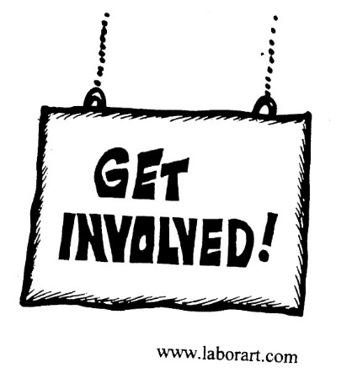
Town Hall Call
CWA D4 AT&T Midwest and Legacy T
Bargaining Update

Tuesday, April 10, 7 p.m. EDT
Hear from CWA President Chris Shelton, District 4 Vice President Linda L. Hinton, T&T Vice President Lisa Bolton, and the Bargaining Chairs of the two committees…and we’ll hear questions from you – the members!

To RSVP: Text Midwestcall to 69866
or
Go to: http://cwa-union.org/ATTMidwestCall

